Q1. Create and Run a Thread using Runnable Interface and Thread class.
A1.
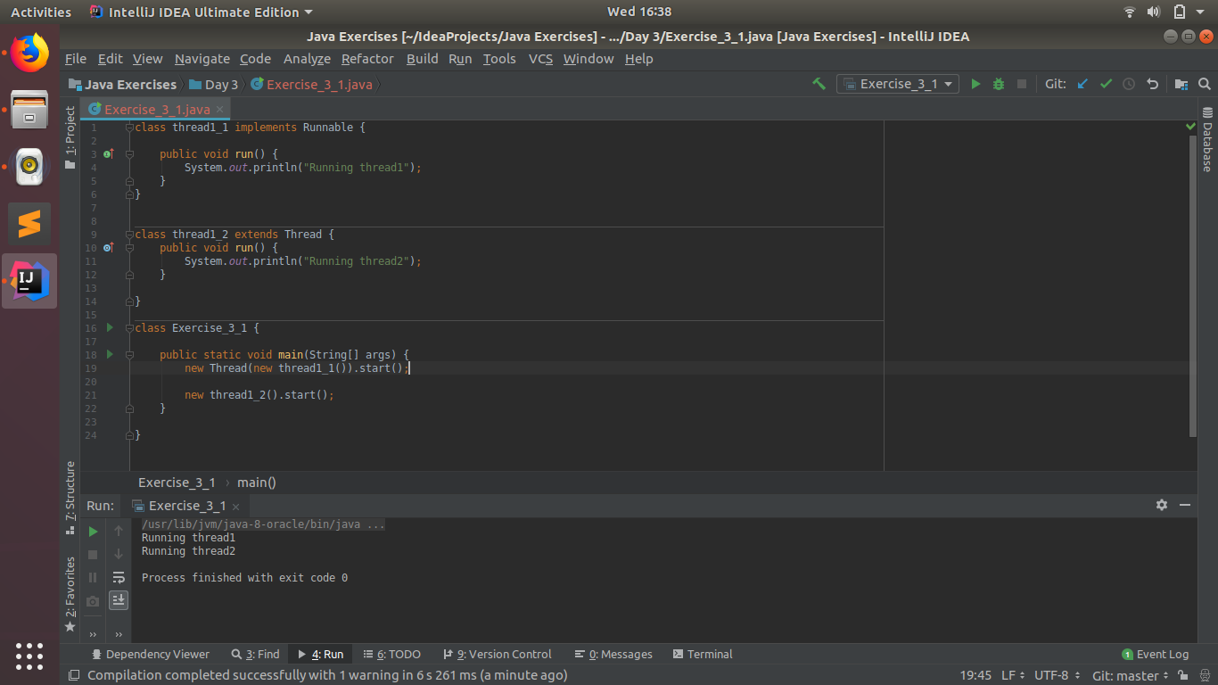
Q2. Use sleep and join methods with thread.
A2.

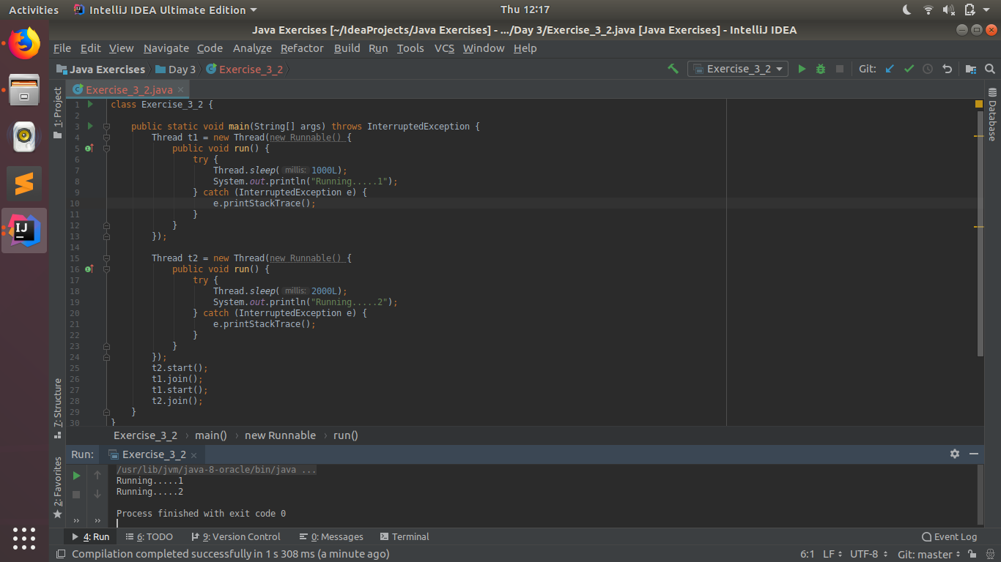

Q3. Use a singleThreadExecutor to submit multiple threads.
A3.

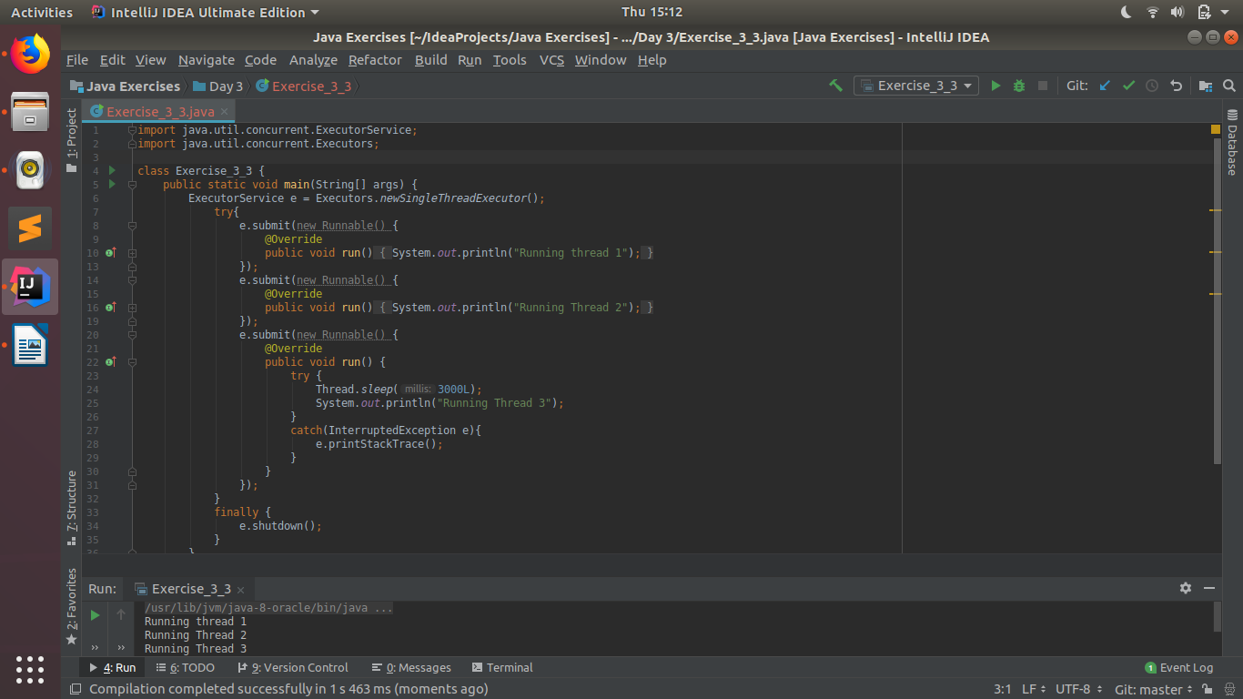
Q4. Try shutdown() and shutdownNow() and observe the difference.
A4.
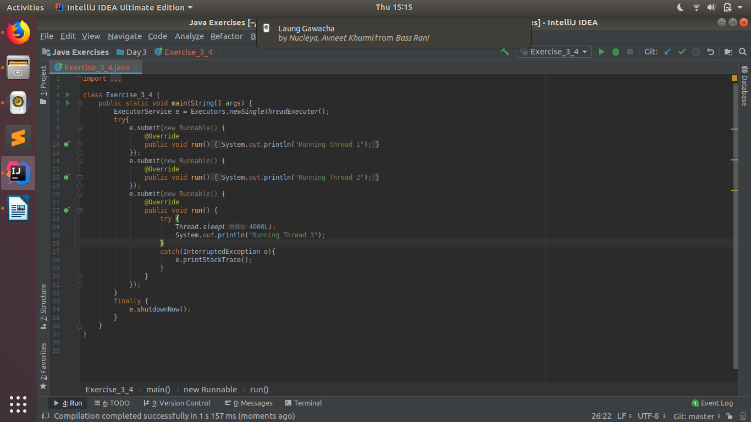

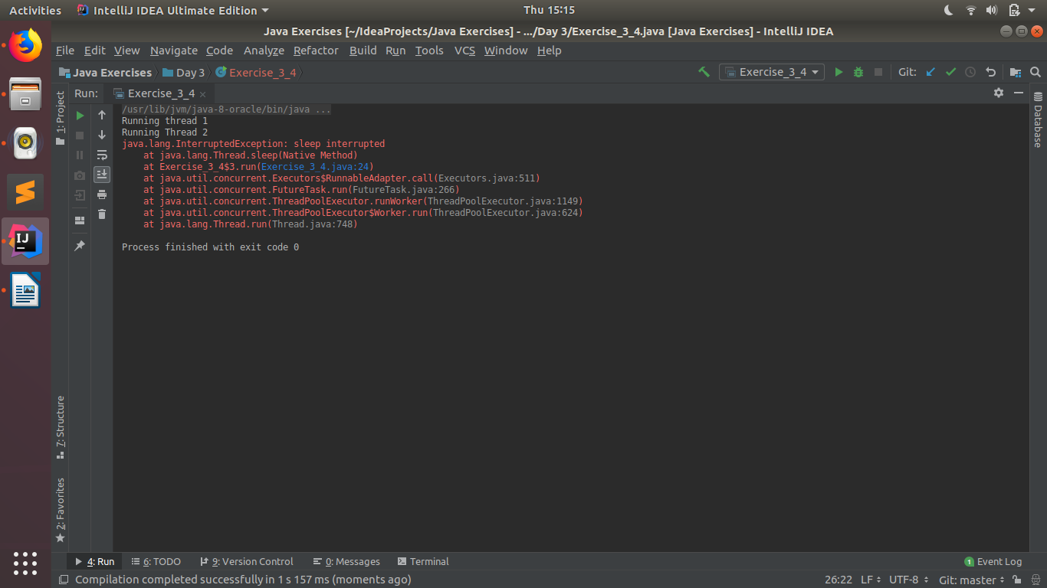
Q5. Use isShutDown() and isTerminated() with ExecutorService.
A5.

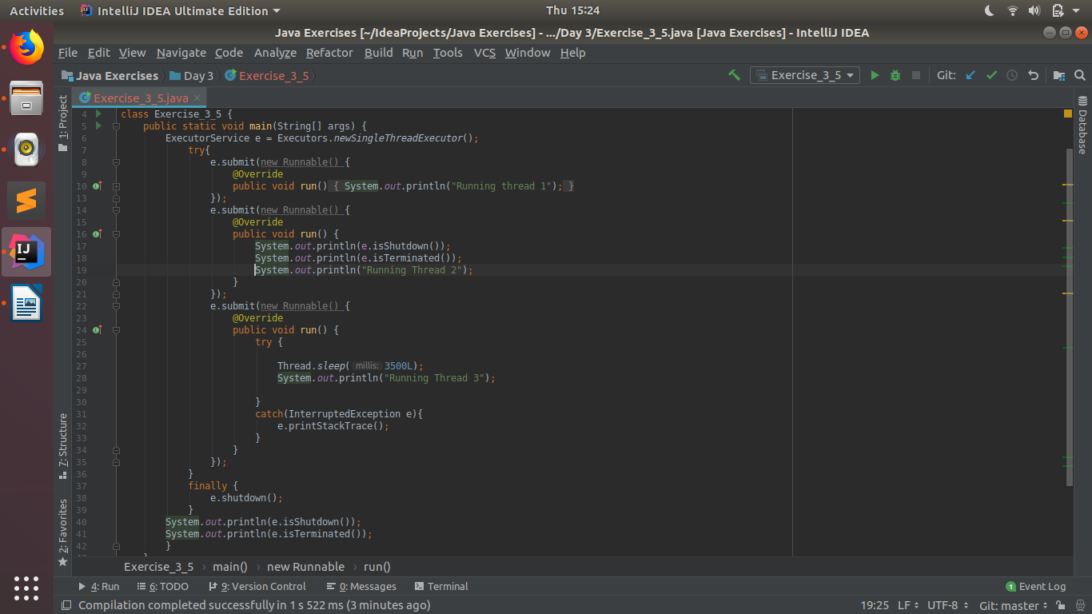

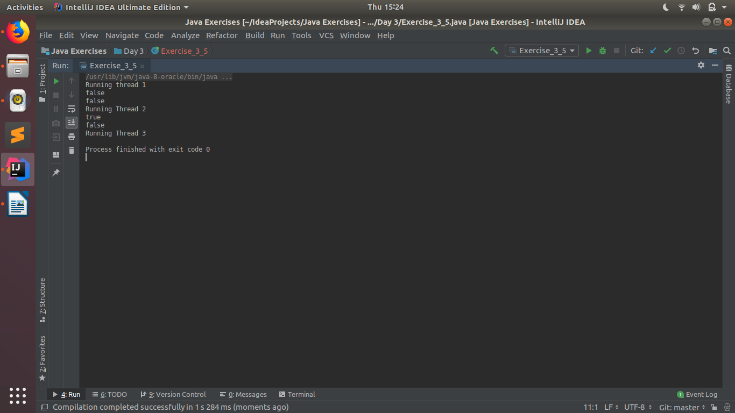
Q6. Return a Future from ExecutorService by using callable and use get(), isDone(), isCancelled() with the Future object to know the status of task submitted.
A6.
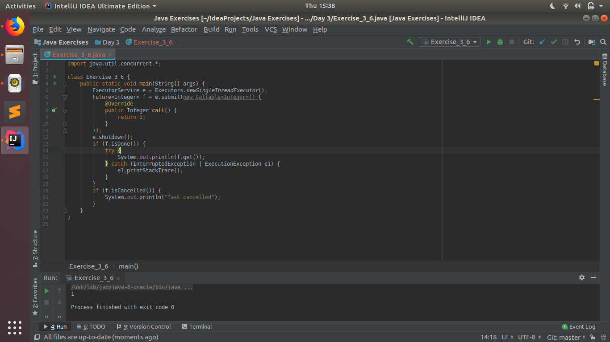

Q7. Submit List of tasks to ExecutorService and wait for the completion of all the tasks.
A7.
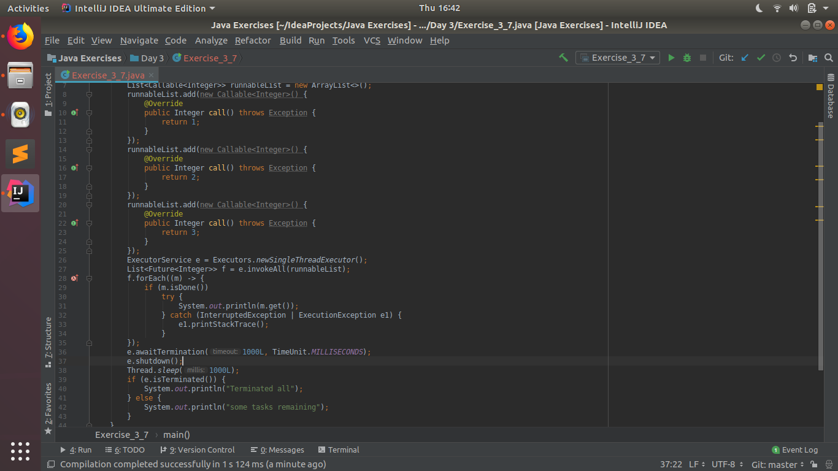
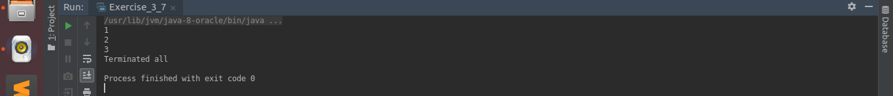
Q8. Schedule task using schedule(), scheduleAtFixedRate() and scheduleAtFixedDelay()
A8.
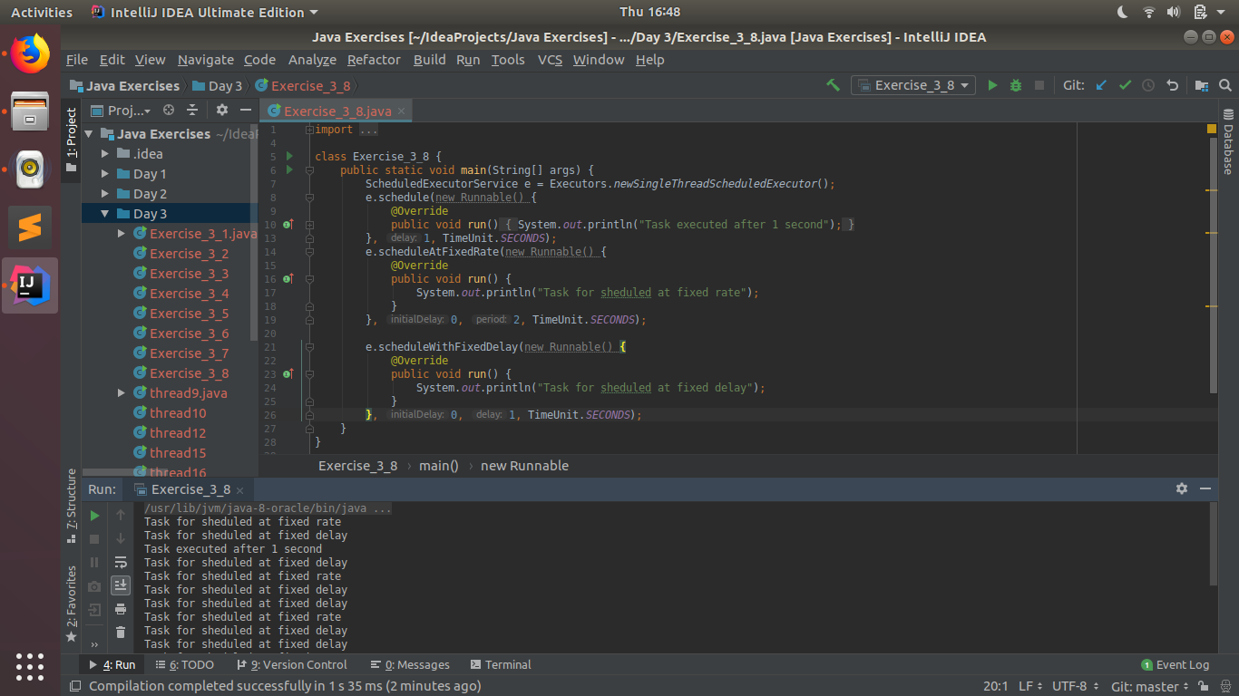

Q9. Increase concurrency with Thread pools using newCachedThreadPool() and newFixedThreadPool().
A9.
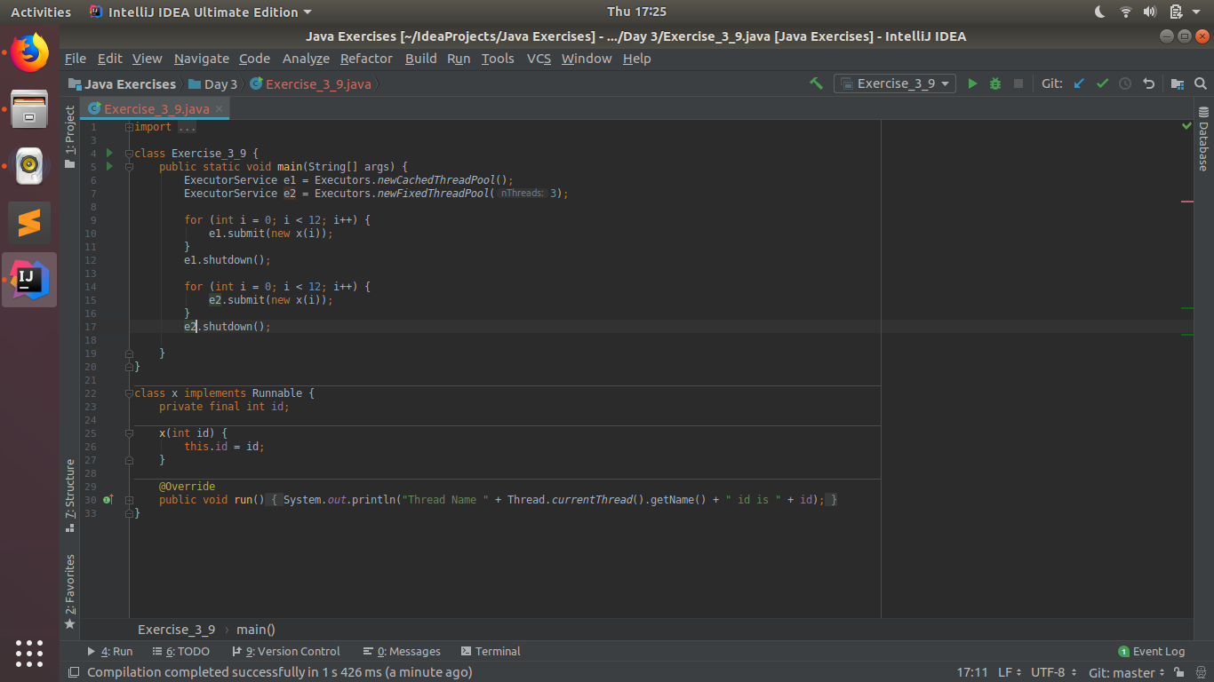
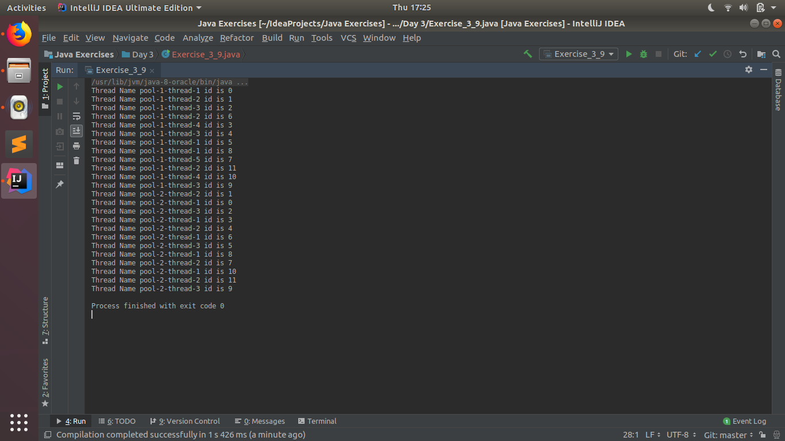

Q10. Use Synchronize method to enable synchronization between multiple threads trying to access method at same time.
A10.
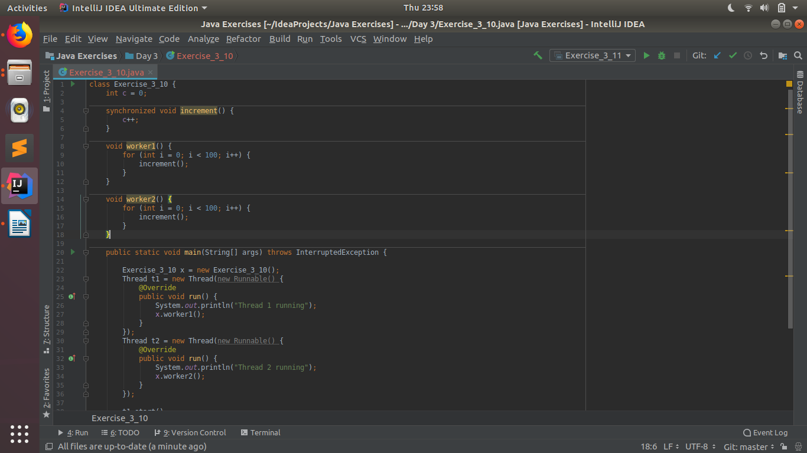
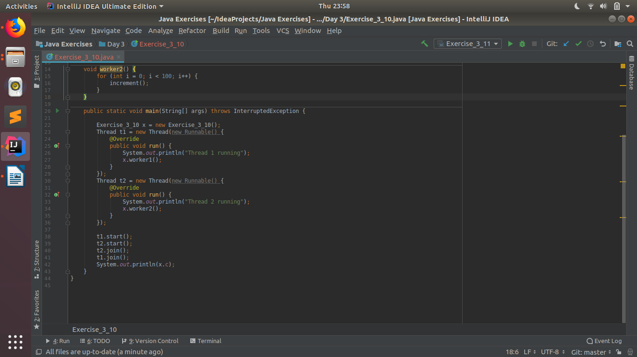
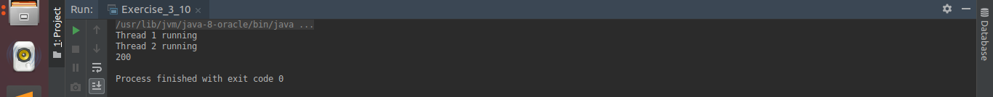

Q11. Use Synchronize block to enable synchronization between multiple threads trying to access method at same time.
A11.
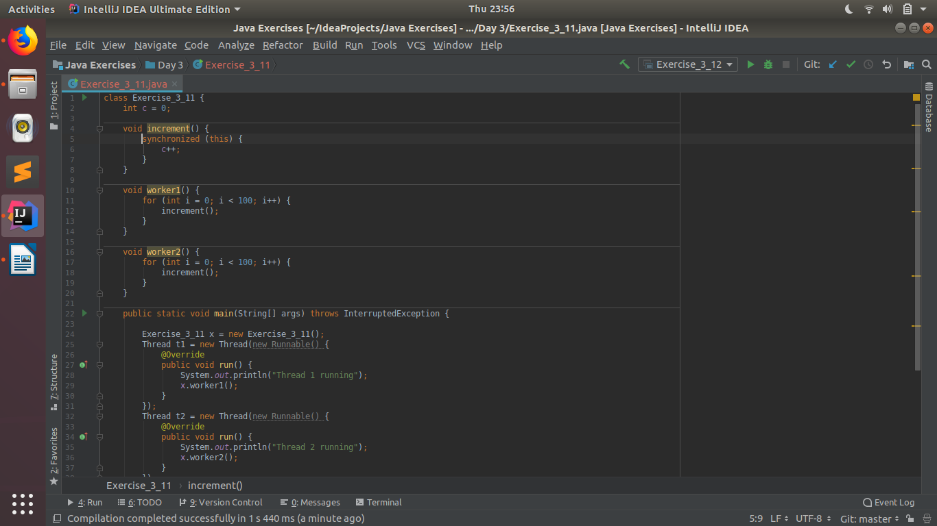
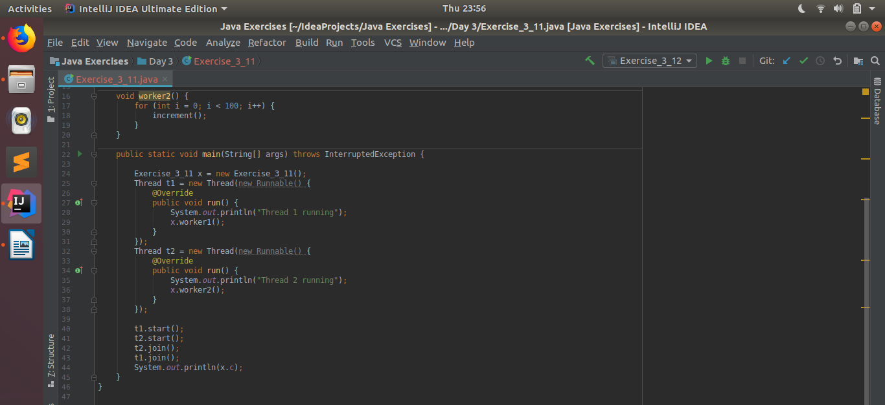

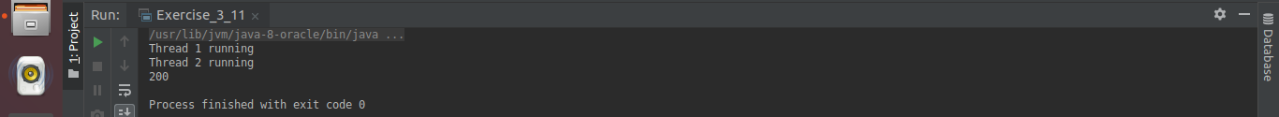

Q12. Use Atomic Classes instead of Synchronize method and blocks.
A12.
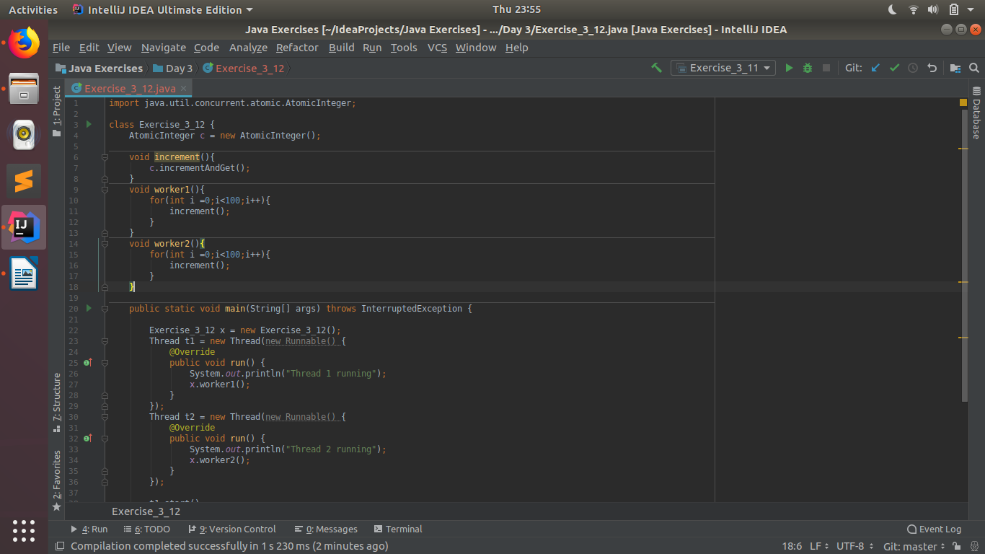
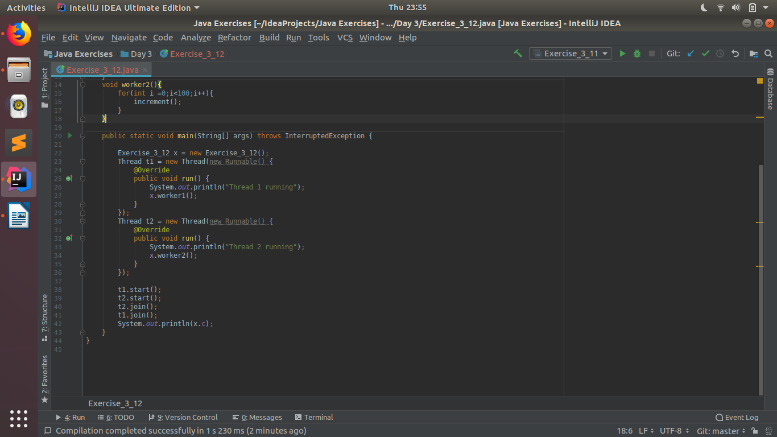
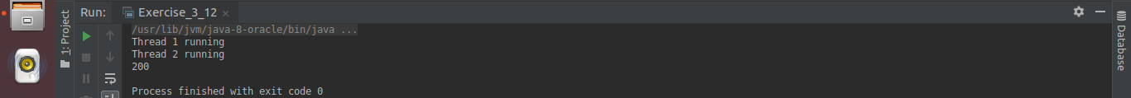

Q13. Coordinate 2 threads using wait() and notify().
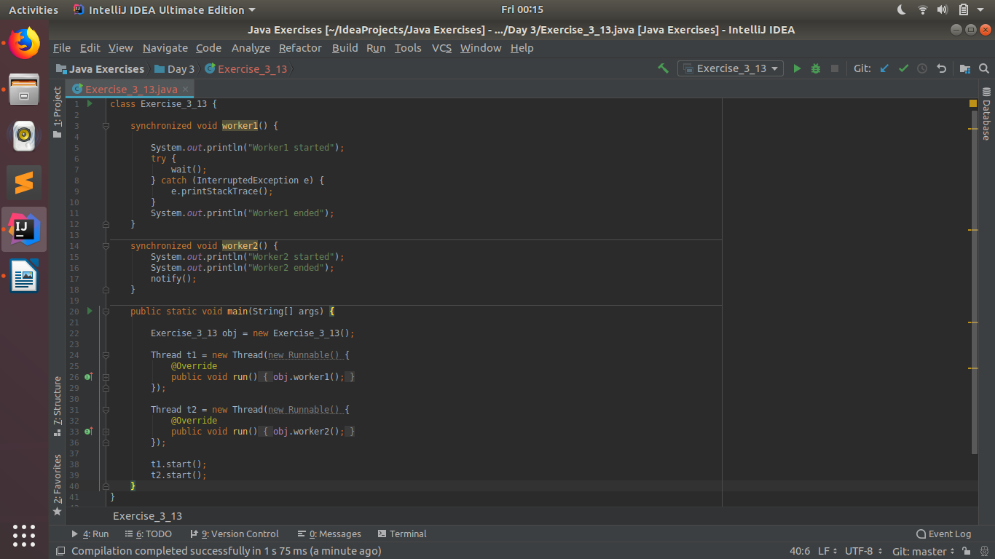
A13.

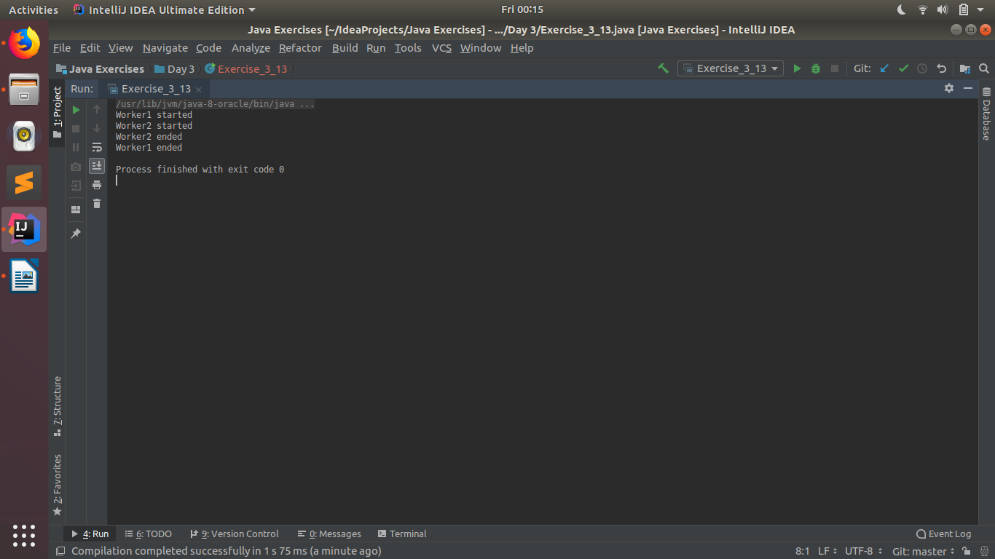

Q14 Coordinate mulitple threads using wait() and notifyAll()
A14.
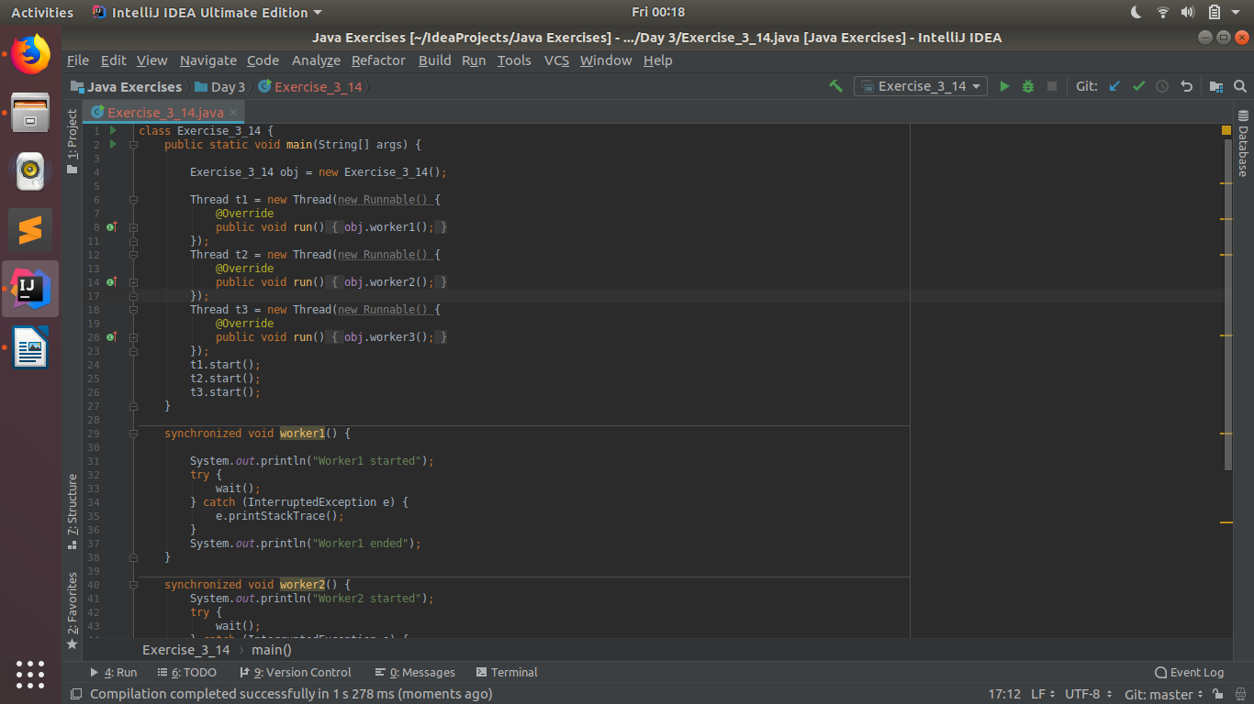
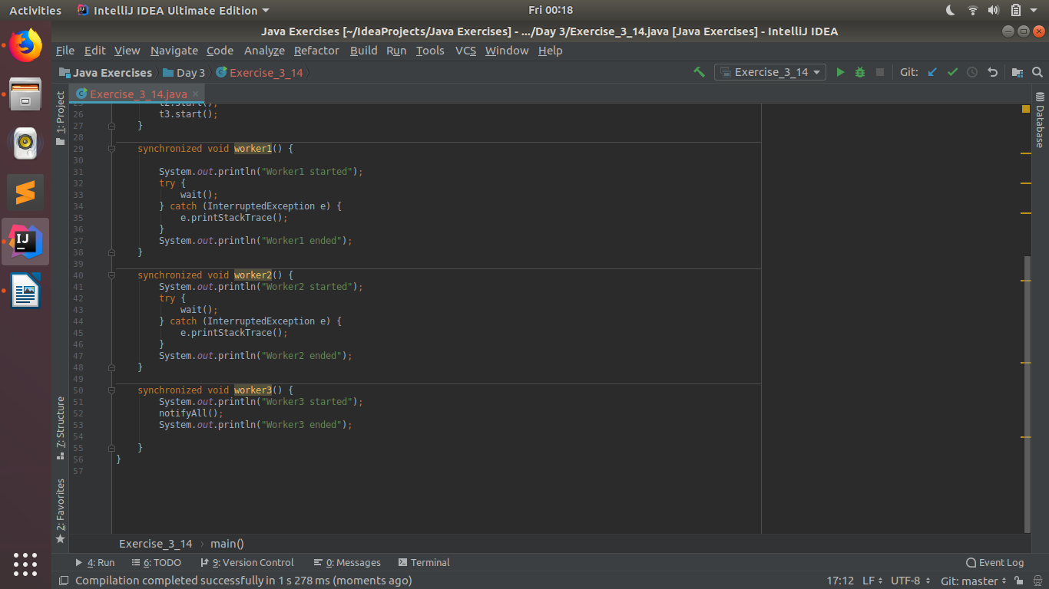
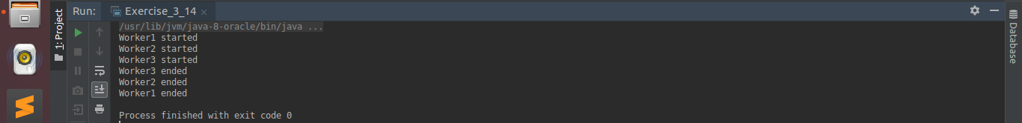

Q15. Use Reentract lock for coordinating 2 threads with signal(), signalAll() and wait().
A15.
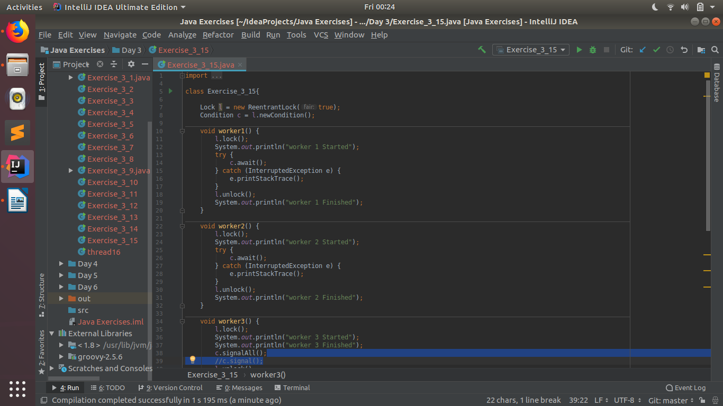
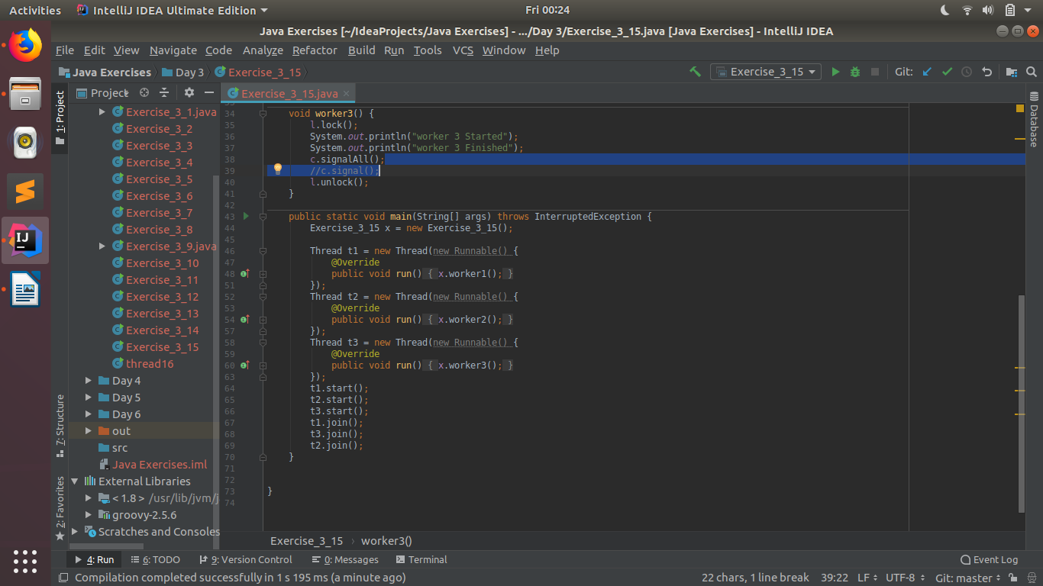
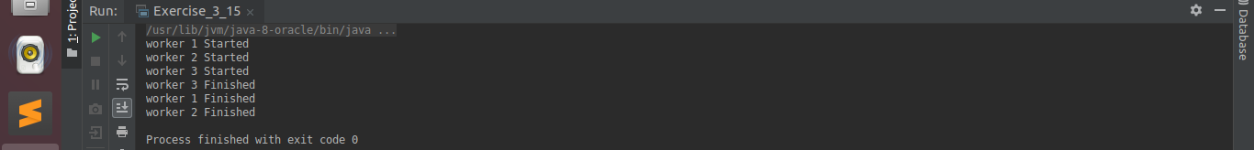

Q16. Create a deadlock and Resolve it using tryLock().
A16.


